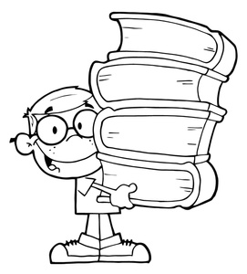
We will spend the year reading a variety of stories representing genres such as adventure, realistic fiction, biographies, and historical fiction just to name a few. Students will also complete several writing assignments that cover a variety of topics. Students will learn new vocabulary and spelling words, complete projects, and will continue to study the eight parts of speech (adjectives, nouns, verbs, etc.).

What you will need for class:
- Pencils • Silent Reading Book
- Notebook Paper • Composition book
- Highlighters • 1 pocket folder with brads
- Post-it Notes

Grading Policy:
All mid-term and final grades will be based on Caroline County’s grading policy. Examples of assignments that I will be collecting and recording for a grade may consist of spelling and/or vocabulary words, warm-ups, notebooks and/or journals, grammar, quizzes/tests, writing assignments, projects, etc.

At Lockerman Middle School, we show Wildcat PRIDE
Prepared-getting ready in advance
Respectful-treating others the way you want to be treated
Independent-thinking or acting for oneself
Disciplined-being in control and doing what is honorable
Empathetic-relating to what another person is going through

Make-up Work:
The student is responsible for making up any missed work. It is the student’s responsibility to ask me about what they missed in class. All assignments will be posted on my classroom webpage. He/she will have the same number of days absent to make up the missed work.

Contact Information:
School Phone: 410-479-2760
Email: stevie_rodis@mail.cl.k12.md.us
Homework Hotline: 410-479-3276
Classroom webpage: http:// msstevierodis.weebly.com/
6th grade webpage: http://www.livebinders.com/play/play?id=919221

I look forward to working with you and your child to make this a great year!

Thank you for your support!
Sincerely,
Ms. Stevie Rodis

Student’s Name: ______________________________________________________

Parent Signature: _______________________________ Date: ______________

